HOLY WEEK AND EASTER 2019


HOLY THURSDAY: EVENING MASS OF THE LORD'S SUPPER

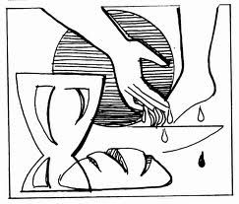
Readings:
1 st Reading: Exodus 12, 1-8.11-14
2 nd Reading: 1 Letter of Paul to the Corinthians 11, 23-26
Gospel: John 13, 1-15
Before the feast of Passover, Jesus knew that his hour had come
to pass from this world to the Father.
He loved his own in the world and he loved them to the end.
The devil had already induced Judas, son of Simon the Iscariot, to hand him over.
So, during supper,
fully aware that the Father had put everything into his power
and that he had come from God and was returning to God,
he rose from supper and took off his outer garments.
He took a towel and tied it around his waist.
Then he poured water into a basin
and began to wash the disciples' feet
and dry them with the towel around his waist.
He came to Simon Peter, who said to him,
"Master, are you going to wash my feet?"
Jesus answered and said to him,
"What I am doing, you do not understand now,
but you will understand later."
Peter said to him, "You will never wash my feet."
Jesus answered him,
"Unless I wash you, you will have no inheritance with me."
Simon Peter said to him,
"Master, then not only my feet, but my hands and head as well."
Jesus said to him,
"Whoever has bathed has no need except to have his feet washed,
for he is clean all over;
so you are clean, but not all."
For he knew who would betray him;
for this reason, he said, "Not all of you are clean."

So when he had washed their feet
and put his garments back on and reclined at table again,
he said to them, "Do you realize what I have done for you?
You call me 'teacher' and 'master,' and rightly so, for indeed I am.
If I, therefore, the master and teacher, have washed your feet,
you ought to wash one another's feet.
I have given you a model to follow,
so that as I have done for you, you should also do."

Comment:
The Lord's Supper ... the reference point of our whole Christian life. In the institution of the Eucharist, Jesus offers himself for the sake of all humanity.
In our life of Christian faith, every act of charity, every act of love has its source in the gift that Jesus makes of himself, symbolized in the breaking of bread and the washing of feet.
Through a service as simple as the washing of the feet, serving those who need us, offering friendship, understanding, solidarity ... we can make possible the presence of Christ in the world. Works of solidarity are signs that may open the way to Christ and transformed humanity.
The celebration of the Eucharist and service are inextricably linked.

Prayer
Oh God and our Father:
When your Son Jesus gave himself to his friends as food and drink for the road, he committed himself to remain with us as the "man-for-others" and as the "Lord-who-serves".
We want to learn from him to give ourselves to our neighbor, to love and serve our brothers without counting the price and to free our brothers and sisters of any evil that enslaves them, as a foretaste of eternal happiness
that, according to your promise, you prepare us
through Jesus Christ, our Lord.

GOOD FRIDAY: LORD'S PASSION

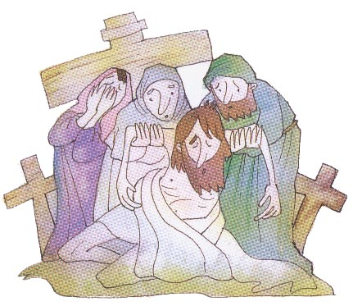
Readings:
1 st Reading Isaiah 52, 13-53, 12
2 nd Reading.: Letter of Paul to the Hebrews 4, 14-16, 5, 7-9
Gospel: The Passion of Our Lord Jesus Christ according to John 18, 1 to 19.4
…Then he handed him over to them to be crucified.
So they took Jesus, and, carrying the cross himself, he went out to what is called the Place of the Skull, in Hebrew, Golgotha.
There they crucified him, and with him two others, one on either side, with Jesus in the middle. Pilate also had an inscription written and put on the cross. It read, "Jesus the Nazorean, the King of the Jews."
Now many of the Jews read this inscription,
because the place where Jesus was crucified was near the city; and it was written in Hebrew, Latin, and Greek.
So the chief priests of the Jews said to Pilate,
"Do not write 'The King of the Jews,' but that he said, 'I am the King of the Jews'." Pilate answered, "What I have written, I have written."
When the soldiers had crucified Jesus,
they took his clothes and divided them into four shares, a share for each soldier.
They also took his tunic, but the tunic was seamless, woven in one piece from the top down. So they said to one another,
"Let's not tear it, but cast lots for it to see whose it will be, "
in order that the passage of Scripture might be fulfilled that says: They divided my garments among them, and for my vesture they cast lots.
This is what the soldiers did.
Standing by the cross of Jesus were his mother
and his mother's sister, Mary the wife of Clopas, and Mary of Magdala.
When Jesus saw his mother and the disciple there whom he loved he said to his mother, "Woman, behold, your son." Then he said to the disciple, "Behold, your mother." And from that hour the disciple took her into his home.
After this, aware that everything was now finished, in order that the Scripture might be fulfilled, Jesus said, "I thirst."
There was a vessel filled with common wine.
So they put a sponge soaked in wine on a sprig of hyssop and put it up to his mouth.
When Jesus had taken the wine, he said, "It is finished." And bowing his head, he handed over the spirit. Now since it was preparation day, in order that the bodies might not remain on the cross on the sabbath, for the sabbath day of that week was a solemn one, the Jews asked Pilate that their legs be broken and that they be taken down. So the soldiers came and broke the legs of the first and then of the other one who was crucified with Jesus. But when they came to Jesus and saw that he was already dead, they did not break his legs, but one soldier thrust his lance into his side, and immediately blood and water flowed out.
An eyewitness has testified, and his testimony is true; he knows that he is speaking the truth,
so that you also may come to believe.
For this happened so that the Scripture passage might be fulfilled: Not a bone of it will be broken. And again another passage says:
They will look upon him whom they have pierced. After this, Joseph of Arimathea, secretly a disciple of Jesus for fear of the Jews,
asked Pilate if he could remove the body of Jesus. And Pilate permitted it. So he came and took his body. Nicodemus, the one who had first come to him at night, also came bringing a mixture of myrrh and aloes weighing about one hundred pounds. They took the body of Jesus and bound it with burial cloths along with the spices, according to the Jewish burial custom.
Now in the place where he had been crucified there was a garden, and in the garden a new tomb, in which no one had yet been buried.
So they laid Jesus there because of the Jewish preparation day; for the tomb was close by.

Comment:
Day of contemplation of the cross. The cross is not far away. The cross is present to us throughout our lives. Christ on the Cross invites us to ponder how to deal with the suffering that life might hold in a spirit of love and giving.

Prayer:
Lord God, merciful Father: We thank you for loving us so much that you gave your only Son, Jesus Christ, to regenerate us with new life through his death and triumphant resurrection.
Continue giving us the strength to overcome in our struggles against sin and evil;
and to carry our crosses in life
together with your Son. Make us live a new life open to service and love of neighbour.

EASTER, THE RESURRECTION OF THE LORD

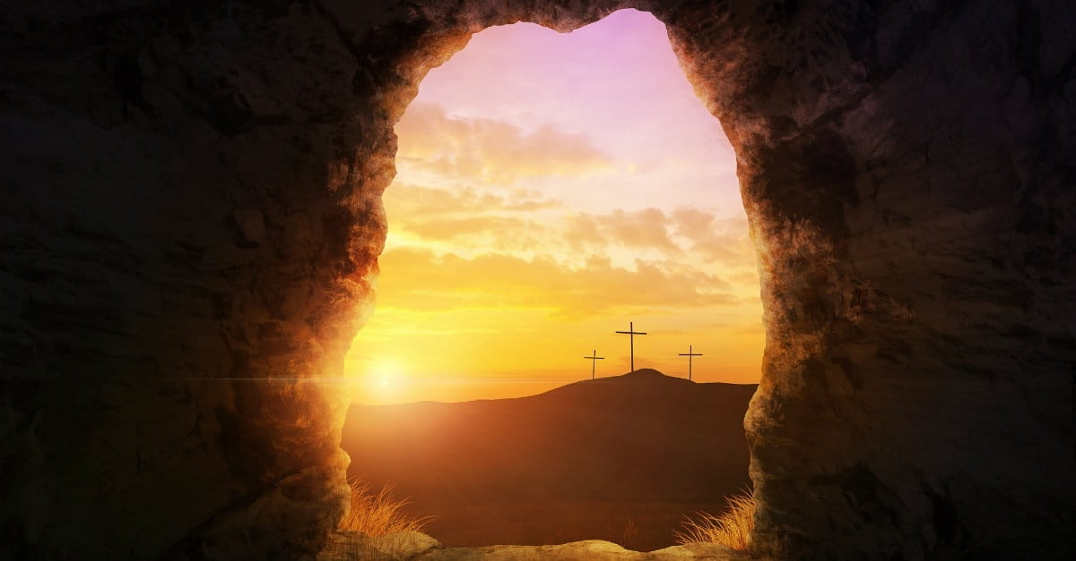

Readings:
1st. reading: Acts 10:34a, 37-43
2nd. Reading: Letter of St. Paul to the Colossians 3:1-4
Gospel according to John 20:1-9
On the first day of the week,
Mary of Magdala came to the tomb early in the morning,
while it was still dark,
and saw the stone removed from the tomb.
So she ran and went to Simon Peter
and to the other disciple whom Jesus loved, and told them,
“They have taken the Lord from the tomb,
and we don’t know where they put him.”
So Peter and the other disciple went out and came to the tomb.
They both ran, but the other disciple ran faster than Peter
and arrived at the tomb first;
he bent down and saw the burial cloths there, but did not go in.
When Simon Peter arrived after him,
he went into the tomb and saw the burial cloths there,
and the cloth that had covered his head,
not with the burial cloths but rolled up in a separate place.
Then the other disciple also went in,
the one who had arrived at the tomb first,
and he saw and believed.
For they did not yet understand the Scripture
that he had to rise from the dead.

IT IS THE GREAT FEAST OF CHRISTIANITY.
Without Easter faith would be meaningless.
The practice of charity, service, sacrifice, the crosses we encounter along the way ... are not simple conformity to a dark reality, but a path that leads to the light, the light that never sets, to the raised Christ that opens the doors to a realm of eternal happiness, not a kingdom that one day will come, but a kingdom that from the experience of faith from the practice of love, we can begin to taste.
It is light, infinite love, the triumph of life over death.

Prayer
Lord our God:
You have enlightened tonight with the glorious light of Christ.
Make us be born with him to a new life,
a life of faithful love in the new Covenant;
and renew us in our body and in our spirit
so that we can be your faithful sons and daughters and we give you unconditional service, together with your risen Son,
Jesus Christ, our Lord.
Easter through God embraces the world, He hugs each of us

HAPPY EASTER!

